
ALLIED MOULDED PRODUCTS, INC.
222 N. Union St.
Bryan, Ohio 43506-1450

Phone 419-636-4217

Fax: 419-636-2450

www.alliedmoulded.com

Installation Instructions for the SliderBox

- Place SliderBox against stud in desired location.

- Drive screws partially into stud.

- Move SliderBox to desired depth.

- When SliderBox is at desired location and depth tighten screws until the box does not move.

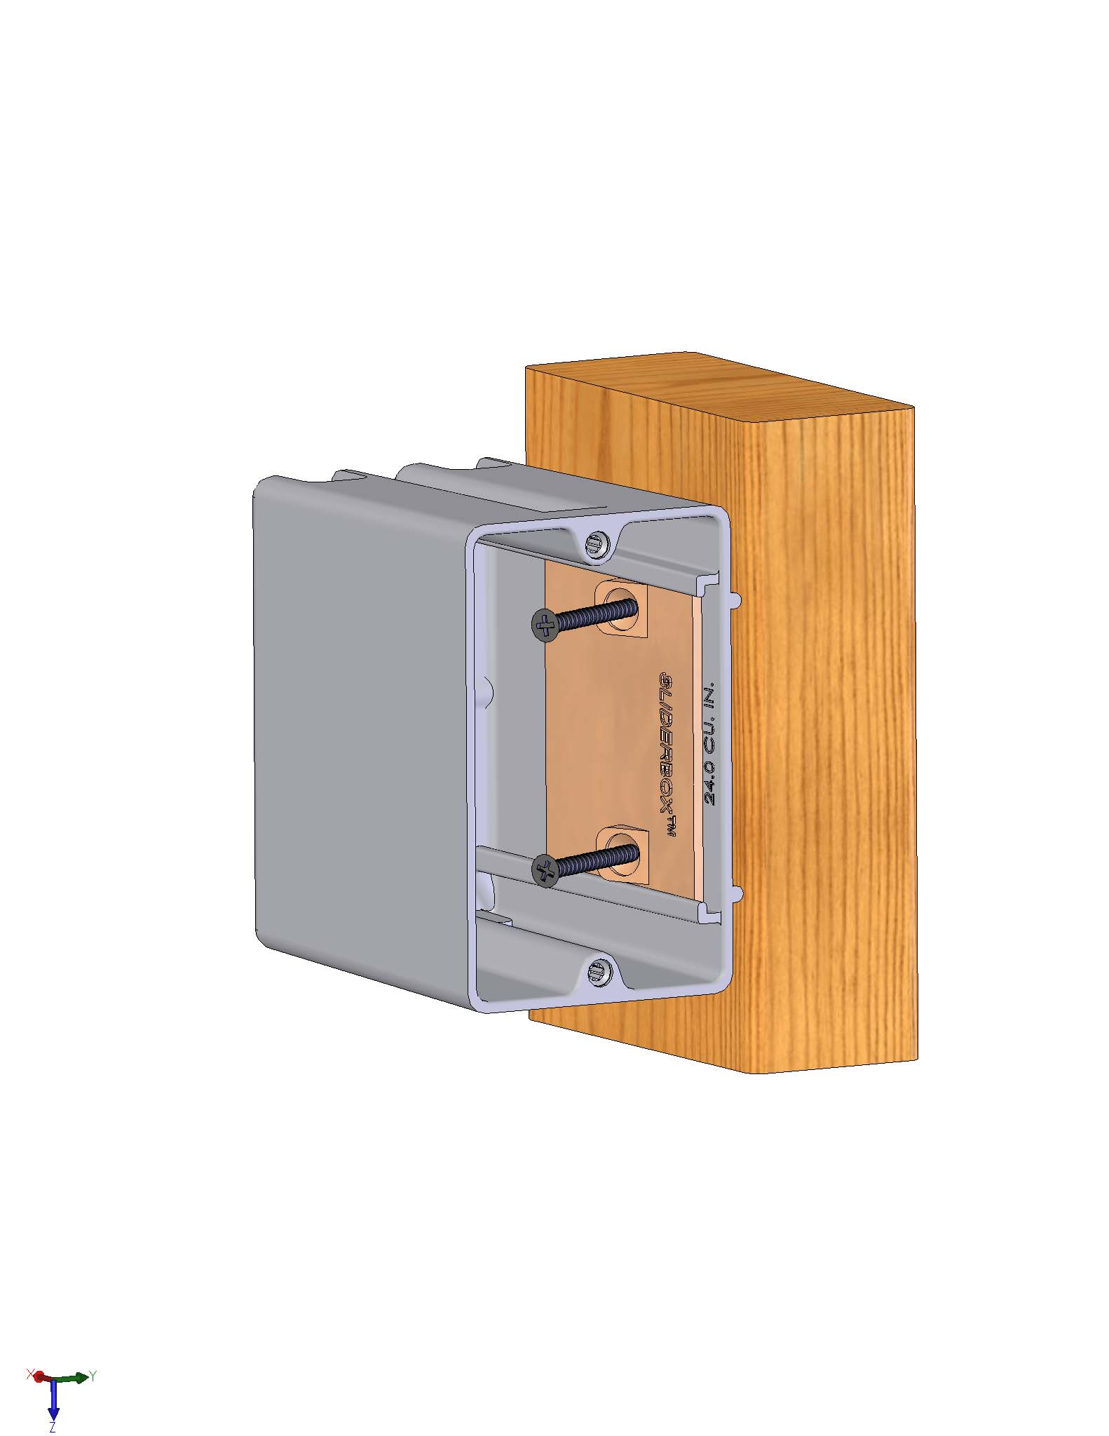
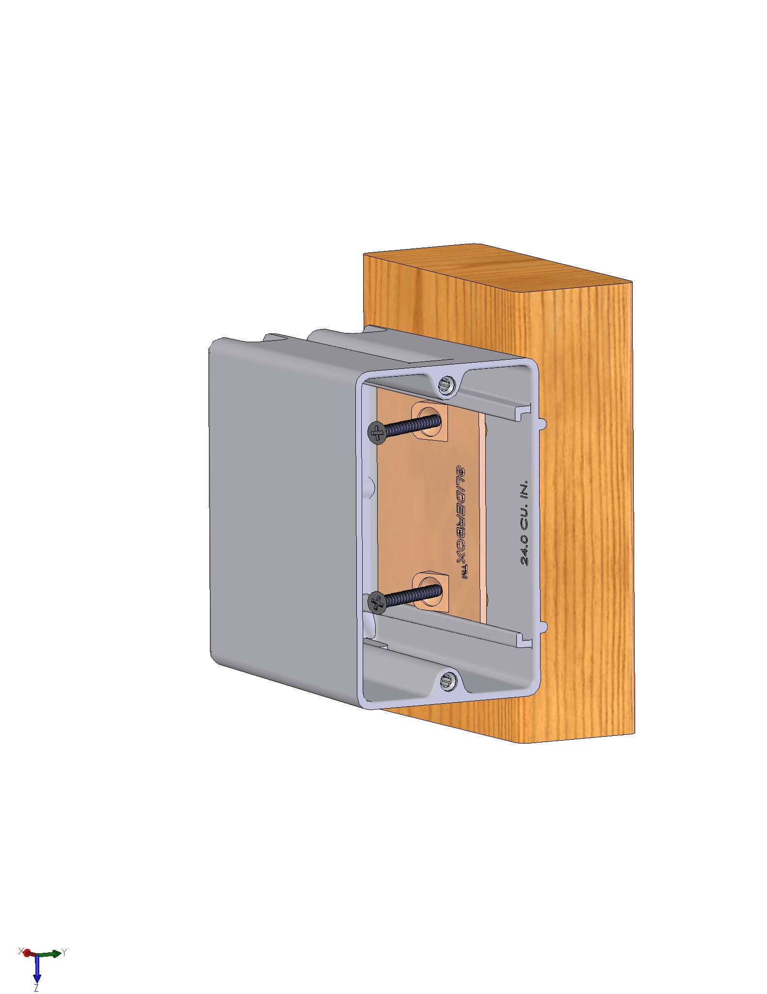
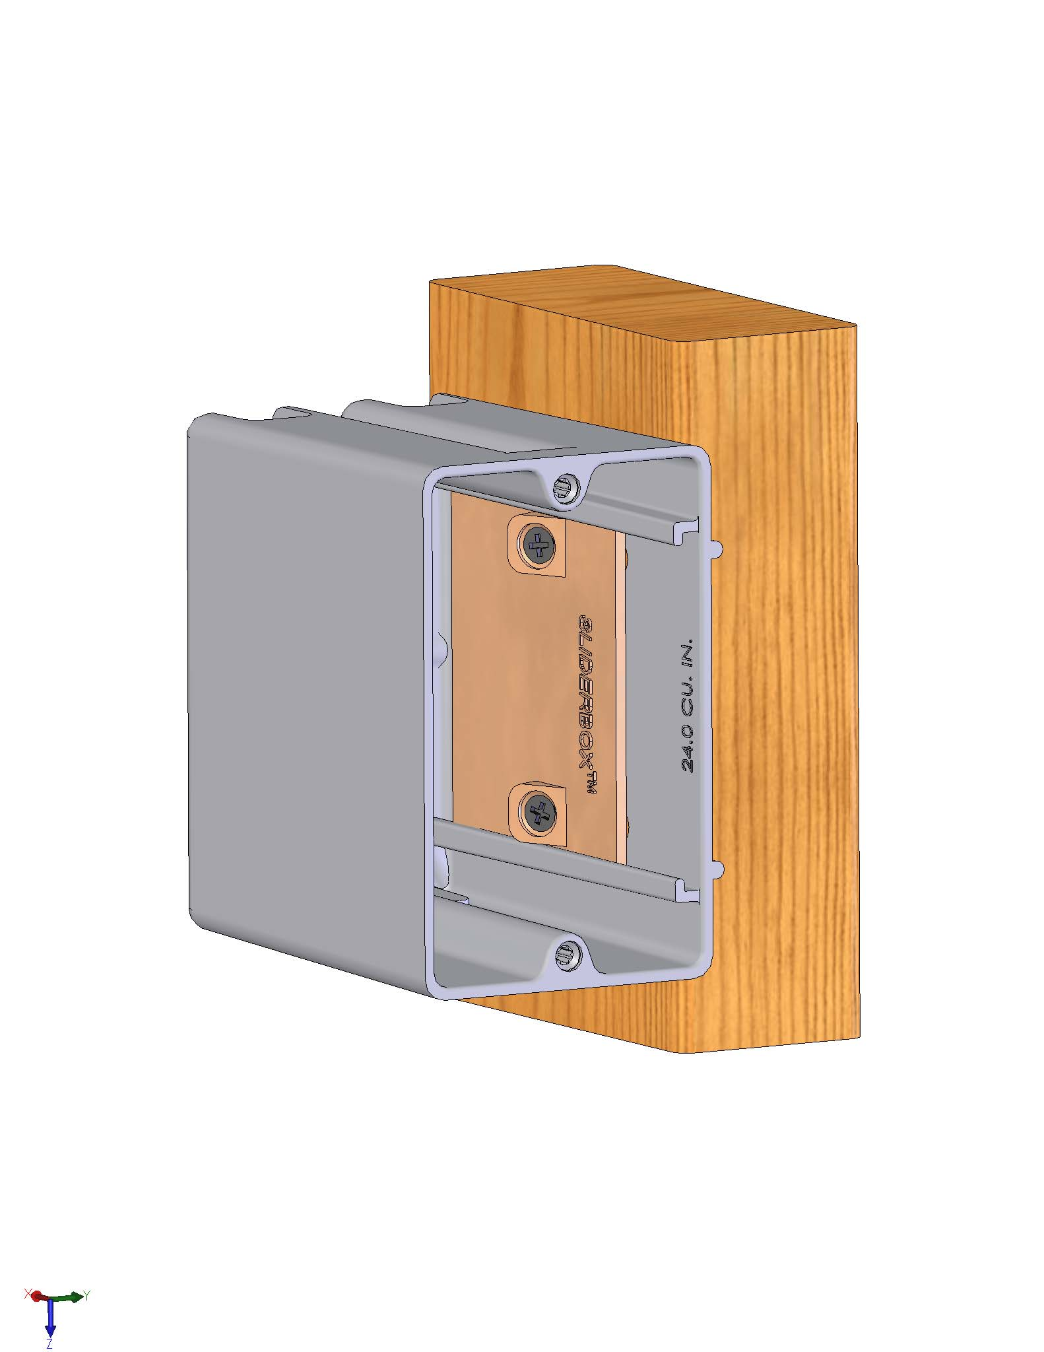
- Tighten screws another 1/2 turn to prevent further movement of the box.
Step 1-2
Step 3
Step 4-6

- Installation is complete.

