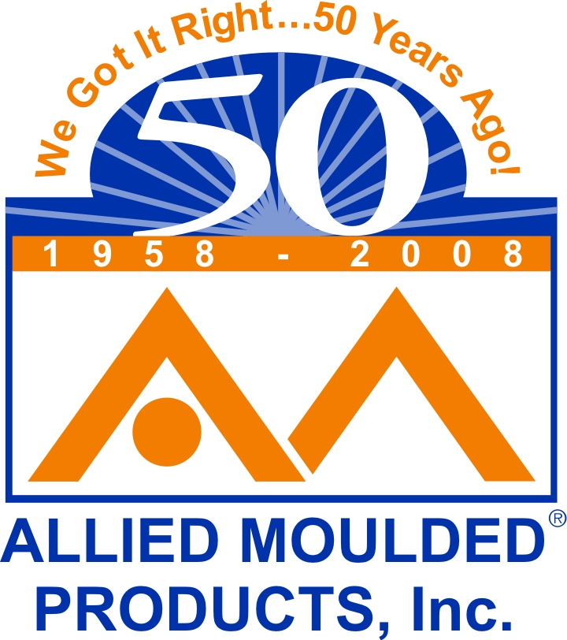 ALLIED MOULDED PRODUCTS, INC.
222 N. Union St.
Bryan, Ohio 43506-1450
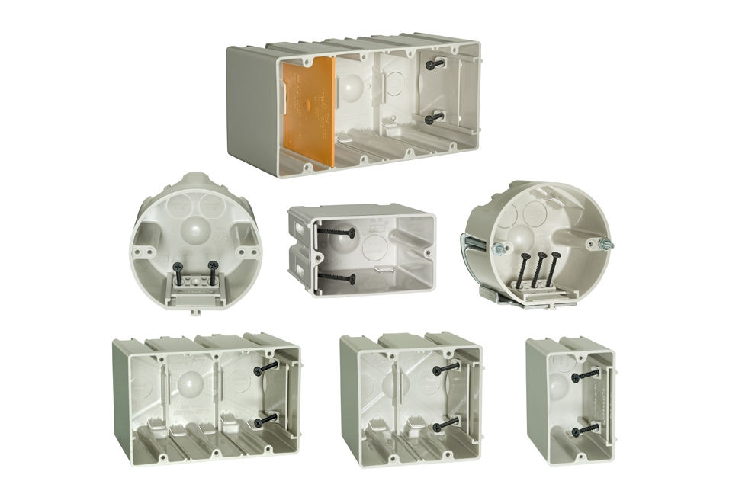
Phone 419-636-4217
Fax: 419-636-2450
www.alliedmoulded.com

Feb 20, 2008

Allied Moulded Products is pleased to announce the launch of a full line of SLIDERBOX® non-metallic adjustable outlet box wall and ceiling products. Standard products include single gang, single gang horizontal mount, multi-gangs, round ceiling fixture support, and round fan support boxes.

SLIDERBOX® is designed for easy movement when wallboard thickness changes. Typical applications include ceramic tile in kitchen or bath, double drywall ceilings, and undetermined baseboards. Unlike other adjustable boxes, SLIDERBOX® requires no removal or relocation of the mounting screws. Simply loosen the screws a couple of turns, slide the box flush with the new wall surface and retighten.

For more information contact:
Allied Moulded Products, Inc.
222 North Union Street
Bryan, Ohio 43506
Ph: 419-636-4217
www.alliedmoulded.com
sales@alliedmoulded.com

